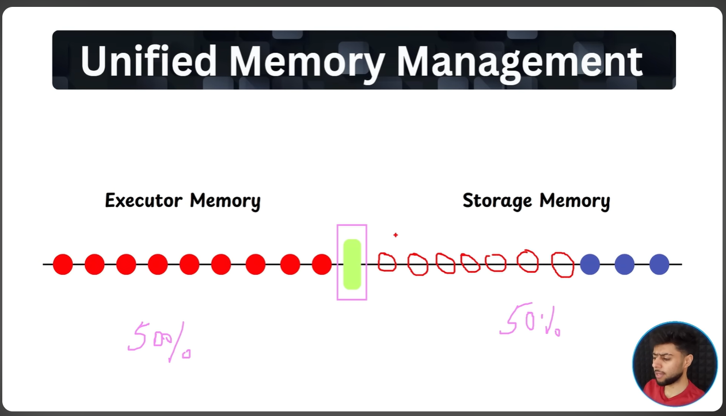
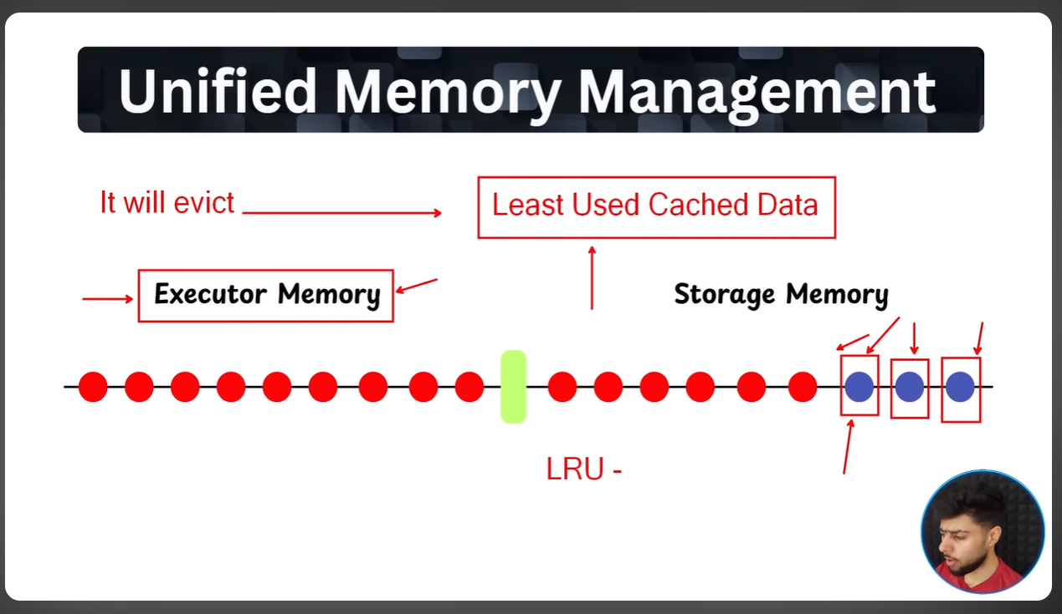

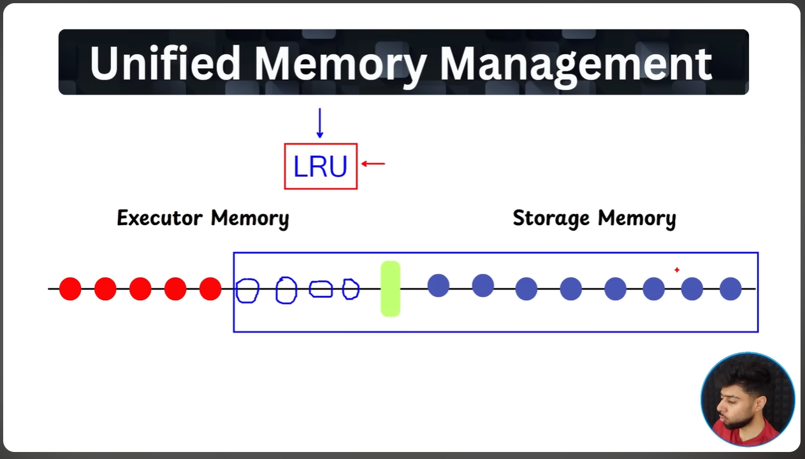
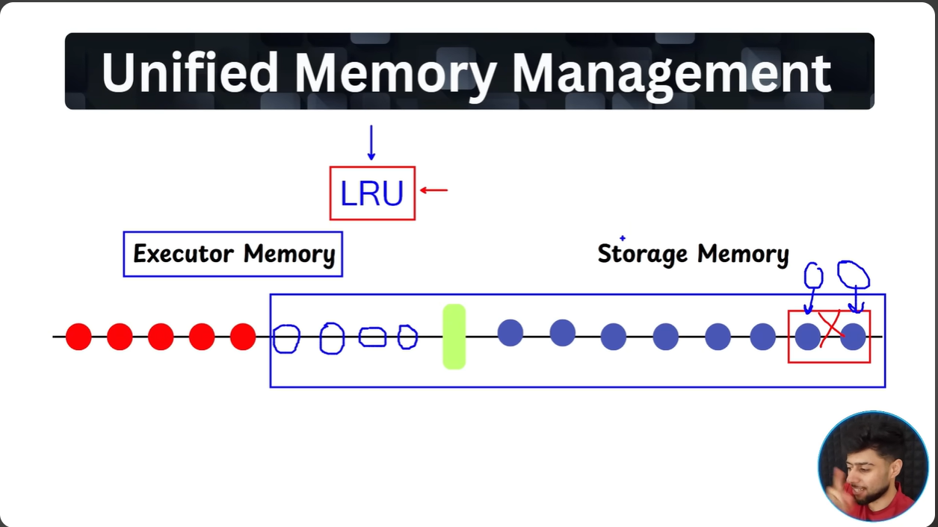

Note : In case if storage memory needs more space ,the storage memory can evict the empty space of executor memory , but storage memory can’t evict the LRU of executor memory in case if executor memory is full , it has to look into its own LRU(least used cache) to evict and acquire

